


TECHNICALPAPER PRESENTATION

Automatic Number Plate Detection and Recognition

Group name: ANPR
Name of the Authors:
1. Abhilasha Sharma e-mail:et17bthcs001@kazirangauniversity.in
2. AnanyaDeori e-mail:et17bthcs008@kazirangauniversity.in
3. Arindom Sharma e-mail:et17bthcs010@kazirangauniversity.in
4. Saket Kumar Jha e-mail:et17bthcs039@kazirangauniversity.in
Contents:
1) Abstract
2) Introduction
3) Proposed method
4) Optical character recognition
5) Character segmentation
6) Character recognition
7) Experimental result

ABSTARCT:

Traffic control and vehicle owner identification has become major problem in every country. Sometimes it becomes difficult to identify vehicle owner who violates traffic rules and drives too fast. Therefore, it is not possible to catch and punish those kinds of people because the traffic personal might not be able to retrieve vehicle number from the moving vehicle because of the speed of the vehicle. Therefore, there is a need to develop Automatic Number Plate Recognition (ANPR) system as a one of the solutions to this problem. There are numerous ANPR systems available today. These systems are based on different methodologies but still it is really challenging task as some of the factors like high speed of vehicle, non-uniform vehicle number plate, language of vehicle number and different lighting conditions can affect a lot in the overall recognition rate. Most of the systems work under these limitations. In this paper, different approaches of ANPR are discussed by considering image size, success rate and processing time as parameters. Towards the end of this paper, an extension to ANPR is suggested.

This paper describes an efficient technique of locating andextracting license plate and recognizing each segmentedcharacter. The proposed model can be subdivided into four parts- Digitization of image, Edge Detection, Separation ofcharacters and Template Matching. In this work, we propose amethod which is based on morphological operations wheredifferent Structuring Elements (SE) are used to maximallyeliminate non-plate region and enhance plate region.Character segmentation is done using Connected ComponentAnalysis. Correlation based template matching technique isused for recognition of characters. This system isimplemented using python image processing. The proposed system ismainly applicable to Indian License Plates

INTRODUCTION:

Number plate recognition is a form of automatic vehicle identification. A number plate is the unique identification of vehicle. It is an image processing technology used to identify vehicles by their own number plates. Real time number plate recognition plays an important role in maintaining law enforcement and maintaining traffic rules. It has wide applications areas such as toll plaza, parking area, highly security areas, boarder’s areas etc. Number plate recognition is designed to identify the number plate and then recognize the vehicle number plate from a moving vehicle automatically. Automatic number plate recognition has three major parts: vehicle number plate extraction, character segmentation and Optical Character Recognition (OCR). Number plate extraction is that stage where vehicle number plate is detected. The detected number plate is pre-processed to remove the noise and then the result is passed to the segmentation part to segment the individually characters from the extracted number plate. The segmented characters are normalized and passed to an OCR algorithm. At last the optical character information will be converted into encoded text. The characters are recognized using Template matching. The final output must be in the form of string of characters

PROPOSED METHOD:
Our proposed model consists of several steps- input, gray-scale conversation, image binarization, noise reduction, optical character recognition,character segmentation, character recognition. The proposed method consists of the following steps:
IMAGE PREPROCESSING:-
- INPUT IMAGE:

Input raw image that is taken from the car. Then, resize the image keeping the aspect ratio same.

- Gray-scale conversation

In any 24-bit color image, each pixel contains the Red (R), Green (G) and Blue (B) color components, each consuming 8 bits of information. From these R, G and B components, 8-bit gray value for each pixel position.

The Gray-scale transformation can not only speed up the subsequent steps, but also transform the various kinds of images to gray image to simplify the process.

- .Image Binarization

The key of image binarization is threshold selection. An appropriate threshold can not only greatly suppress the noise, but can clearly divide the image into the target and background, leading to reduce the computational time. Digitization of an image into a binary matrix of specified dimensions makes the input image invariant of its actual dimensions. The image of whatever size gets transformed into a binary matrix of fixed pre-determined dimensions. This establishes uniformity in the dimensions of the input. The input image is sampled into a binary window, which forms the input to the recognition system.
(D)Noise Reduction
Our first step for morphological edge detection is Median Filtering to remove noise. Median filter is a non-linear filter, which replaces the gray value of a pixel by the median of the gray values of its neighbors. In this work, a 3 × 3 convolution mask is used to get eight neighbors of a pixel and their corresponding gray values. This operation removes salt-and- pepper noise from the image.

OPTICAL CHARACTER RECOGNITION:

The optical character recognition is a recognition method in which the input is an image and the output is string of character. OCR is a process which separates the different characters from each other taken from an image. Template matching is one of the approaches of OCR. The cropped image is compared with the template data stored in database. OCR automatically identifies and recognizes the characters without any indirect input. The characters on the number plate have uniform fonts then the OCR for number plate recognition is less complex as compared to other methods.

CHARACTER SEGMENTATION:

In case of character segmentation, the characters constitute the foreground components. So character segmentation is basically the isolation of the characters within the image component. Connected Component Labeling (CCL) is the process through which the characters are segmented from the background and also the individual characters are labeled distinctly to mark or identify them separately for future use. Connected Component Labeling (CCL) algorithm, or Connected Component Analysis (CCA) is an algorithmic application of graph theory, where subsets of connected components are uniquely labeled based on a given heuristic. The outcome of CCL algorithm is a set of foreground segments which are supposed to be the characters or digits within the license plate.

CHARACTER RECOGNITION:

In our proposed model character recognition is done by template matching which is a classical pattern recognition method. The outcome of the CCL module in terms of foreground segments is to be recognized using template matching. In our proposed model, pixel values of template characters (A-Z, 0-9) are stored in vector such that vector location 1 stores value for character A, location 2 for B and so on. Firstly, the sample is classified and then the recognized characters are normalized by the template size in the character database. It will match with all templates and calculate their similarity. Each data segment corresponding to each character is matched with all the 36 data templates in the library. Finally the best match will be chosen as the result.

EXPERIMENTAL RESULT:

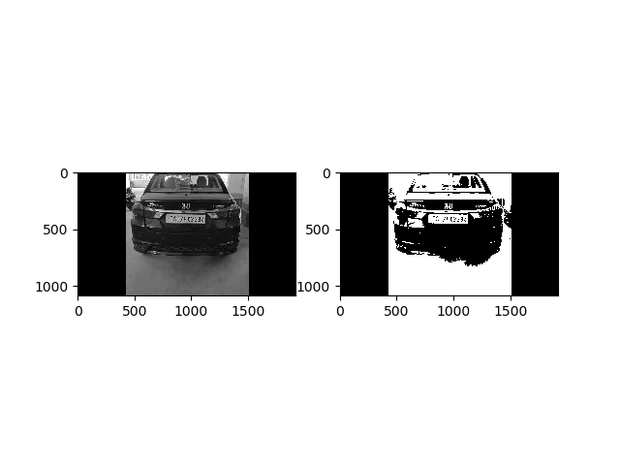
Figure 2: Binary Image
Figure 1: Black and White

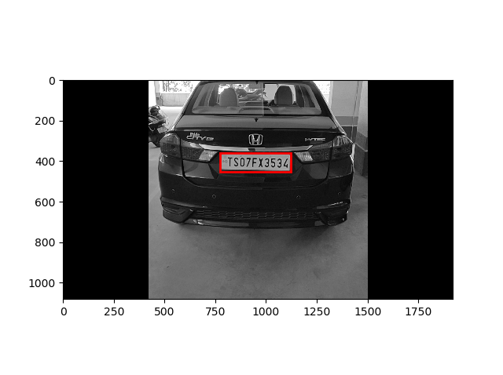
Figure 3: Captured Plate

